**Ex No : 2 A**

**Date : 12.02.2025**

**Handling Event and Objects Using JavaScript**

**AIM:**

To create a webpage to handle events and objects using Javascript

**PROCEDURE:**

The event handling functions and various events available in Java Script are listed below.

|  |  |  |
| --- | --- | --- |
| **Events** | **Event Listener** | **DESCRIPTION** |
| Click | element.addEventListener("click", callback) | Triggered when an element is clicked. |
| **dbclick** | element.addEventListener("dblclick", callback) | Triggered when an element is double-clicked. |
| **Mouseover** | element.addEventListener("mouseover", callback) | Fires when the mouse pointer enters the element. |
| **Mouseout** | element.addEventListener("mouseout", callback) | Fires when the mouse pointer leaves the element. |
| **MouseDown** | element.addEventListener("mousedown", callback) | Fires when the mouse is moved down the element. |
| **MouseUP** | element.addEventListener("mouseup", callback) | Fires when a mouse button is pressed on the element. |
| **MouseCenter** | element.addEventListener("mousecenter", callback) | Fires when a mouse button is released over the element. |
| **MouseLeave** | element.addEventListener("mouseleave", callback) | **S**imilar to mouseover, but does not bubble. |

**SOURCE CODE :**

<!DOCTYPE html>

<html lang="en">

<head>

<meta charset="UTF-8">

<meta name="viewport" content="width=device-width, initial-scale=1.0">

<title>Stack Overflow Style Question</title>

<link rel="stylesheet" href="styles.css">

</head>

<body>

<div class="question-container">

<div class="votes">

<button class="upvote">▲</button>

<span class="vote-count">0</span>

<button class="downvote">▼</button>

</div>

<div class="question-content">

<h2 class="question-title">How does event delegation work in JavaScript?</h2>

<p class="author">Asked by <span class="author-name">JohnDoe</span></p>

<div class="tags">

<span class="tag">javascript</span>

<span class="tag">event-handling</span>

<span class="tag">dom</span>

</div>

</div>

</div>

<script src="script.js"></script>

</body>

</html>

**Script.js**

document.addEventListener("DOMContentLoaded", () => {

const upvoteBtn = document.querySelector(".upvote");

const downvoteBtn = document.querySelector(".downvote");

const voteCount = document.querySelector(".vote-count");

const questionTitle = document.querySelector(".question-title");

let votes = 0;

// Click event for upvote

upvoteBtn.addEventListener("click", () => {

votes++;

voteCount.textContent = votes;

});

// Click event for downvote

downvoteBtn.addEventListener("click", () => {

votes--;

voteCount.textContent = votes;

});

// Double-click event on the question title

questionTitle.addEventListener("dblclick", () => {

alert("You double-clicked the question!");

});

// Mouseover event on the question title

questionTitle.addEventListener("mouseover", () => {

questionTitle.style.color = "red";

});

// Mouseout event to reset the title color

questionTitle.addEventListener("mouseout", () => {

questionTitle.style.color = "#0077cc";

});

});

**OUTPUT 1 :**

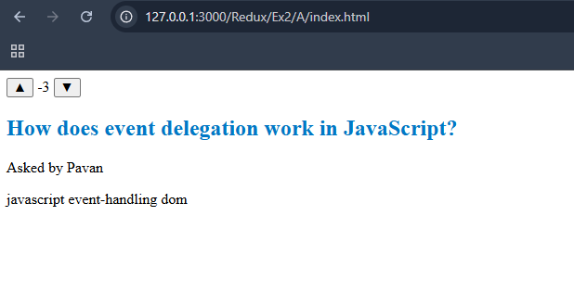

**OUTPUT 2 :**

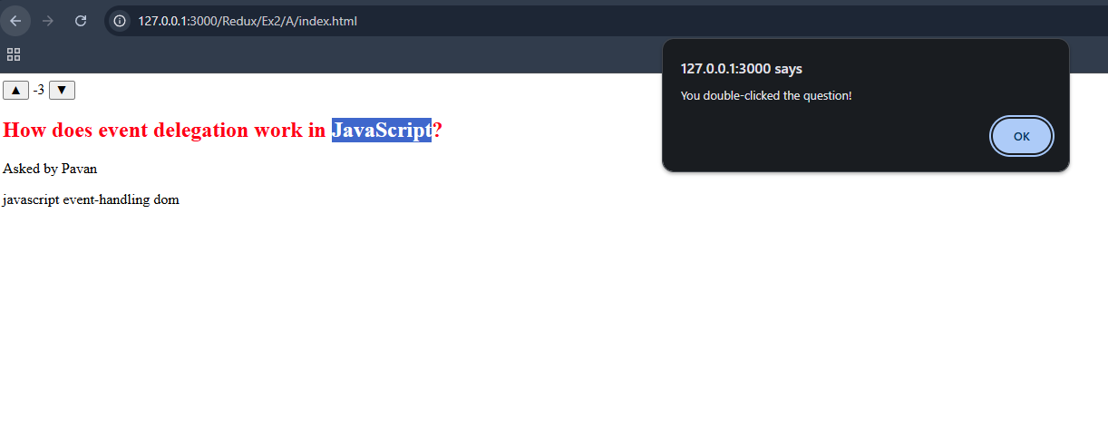

**RESULT :**

**The program has been successfully executed and the output is verified.**